**Date:29/2/24 EXPERIMENT 8**

**Name:Rithika shree**

**21R231**

**Face and Object Detection**

**Aim:**

To perform Face and Object Detection using Haar Cascade and Object Detection using YOLO V5 Deep Learning Library.

# **Software/ Packages Used:**

1. Google Colaboratory
2. Libraries used:
   * Opencv – python
   * Numpy
   * Matplotlib
   * Tensorflow

# **Programs:**

# **Haar Cascade Based Face Detection:**

**DATA COLLECTOR**

import cv2

import os

import time

#####################################################

#myPath = 'data/images' # Rasbperry Pi: '/home/pi/Desktop/data/images'

myPath = r'C:\Users\rithi\PycharmProjects\pythonProject6\images' # Rasbperry Pi: '/home/pi/Desktop/data/images'

cameraNo = 0

cameraBrightness = 180

moduleVal = 10 # SAVE EVERY iTH FRAME TO AVOID REPETITION

minBlur = 500 # SMALLER VALUE MEANS MORE BLURRINESS PRESENT

grayImage = False # IMAGES SAVED COLORED OR GRAY

saveData = True # SAVE DATA FLAG

showImage = True # IMAGE DISPLAY FLAG

imgWidth = 180

imgHeight = 120

#####################################################

global countFolder

cap = cv2.VideoCapture(cameraNo)

cap.set(3, 640)

cap.set(4, 480)

cap.set(10, cameraBrightness)

count = 0

countSave = 0

def saveDataFunc():

global countFolder

countFolder = 0

while os.path.exists(myPath + str(countFolder)):

countFolder += 1

os.makedirs(myPath + str(countFolder))

if saveData: saveDataFunc()

while True:

success, img = cap.read()

img = cv2.resize(img, (imgWidth, imgHeight))

if grayImage: img = cv2.cvtColor(img, cv2.COLOR_BGR2GRAY)

if saveData:

blur = cv2.Laplacian(img, cv2.CV_64F).var()

if count % moduleVal == 0 and blur > minBlur:

nowTime = time.time()

cv2.imwrite(myPath + str(countFolder) +

'/' + str(countSave) + "_" + str(int(blur)) + "_" + str(nowTime) + ".png", img)

countSave += 1

count += 1

if showImage:

cv2.imshow("Image", img)

#if cv2.waitKey(1) & amp; 0xFF == ord('q'):

if cv2.waitKey(1) & 0xFF == ord('q'):

break

cap.release()

cv2.destroyAllWindows()

**TRAINER CODE**

import cv2

################################################################

#path = 'Resources/haarcascades/haarcascade_frontalface_default.xml' # PATH OF THE CASCADE

path = r'C:\Users\rithi\PycharmProjects\pythonProject6\cascade\classifier/cascade.xml'

cameraNo = 0 # CAMERA NUMBER

#objectName = 'Arduino' # OBJECT NAME TO DISPLAY

objectName = 'specs'

frameWidth = 640 # DISPLAY WIDTH

frameHeight = 480 # DISPLAY HEIGHT

color = (255, 0, 255)

#################################################################

cap = cv2.VideoCapture(cameraNo)

cap.set(3, frameWidth)

cap.set(4, frameHeight)

def empty(a):

pass

# CREATE TRACKBAR

cv2.namedWindow("Result")

cv2.resizeWindow("Result", frameWidth, frameHeight + 100)

cv2.createTrackbar("Scale", "Result", 400, 1000, empty)

cv2.createTrackbar("Neig", "Result", 8, 50, empty)

cv2.createTrackbar("Min Area", "Result", 0, 100000, empty)

cv2.createTrackbar("Brightness", "Result", 180, 255, empty)

# LOAD THE CLASSIFIERS DOWNLOADED

cascade = cv2.CascadeClassifier(path)

while True:

# SET CAMERA BRIGHTNESS FROM TRACKBAR VALUE

cameraBrightness = cv2.getTrackbarPos("Brightness", "Result")

cap.set(10, cameraBrightness)

# GET CAMERA IMAGE AND CONVERT TO GRAYSCALE

success, img = cap.read()

gray = cv2.cvtColor(img, cv2.COLOR_BGR2GRAY)

# DETECT THE OBJECT USING THE CASCADE

scaleVal = 1 + (cv2.getTrackbarPos("Scale", "Result") / 1000)

neig = cv2.getTrackbarPos("Neig", "Result")

objects = cascade.detectMultiScale(gray, scaleVal, neig)

# DISPLAY THE DETECTED OBJECTS

for (x, y, w, h) in objects:

area = w * h

minArea = cv2.getTrackbarPos("Min Area", "Result")

if area > minArea:

cv2.rectangle(img, (x, y), (x + w, y + h), color, 3)

cv2.putText(img, objectName, (x, y - 5), cv2.FONT_HERSHEY_COMPLEX_SMALL, 1, color, 2)

roi_color = img[y:y + h, x:x + w]

cv2.imshow("Result", img)

if cv2.waitKey(1) & 0xFF == ord('q'):

# if cv2.waitKey(1) & amp: 0xFF == ord('q'):

break

# **OUTPUT**

# 

# **HAAR CLASSIFIER**

import cv2

face_classifier = cv2.CascadeClassifier(cv2.data.haarcascades + "haarcascade_frontalface_default.xml")

eye_classifier = cv2.CascadeClassifier(cv2.data.haarcascades + "haarcascade_eye.xml")

# capture frames from a camera

cap = cv2.VideoCapture(0,cv2.CAP_DSHOW)

# loop runs if capturing has been initialized.

while 1:

# reads frames from a camera

ret, img = cap.read()

# convert to gray scale of each frames

gray = cv2.cvtColor(img, cv2.COLOR_BGR2GRAY)

# Detects faces of different sizes in the input image

faces = face_classifier.detectMultiScale(gray, 1.3, 5)

for (x, y, w, h) in faces:

# To draw a rectangle in a face

cv2.rectangle(img, (x, y), (x + w, y + h), (255, 255, 0), 2)

roi_gray = gray[y:y + h, x:x + w]

roi_color = img[y:y + h, x:x + w]

# Detects eyes of different sizes in the input image

eyes = eye_classifier.detectMultiScale(roi_gray)

# To draw a rectangle in eyes

for (ex, ey, ew, eh) in eyes:

cv2.rectangle(roi_color, (ex, ey), (ex + ew, ey + eh), (0, 127, 255), 2)

# Display an image in a window

cv2.imshow('img', img)

# Wait for Esc key to stop

if cv2.waitKey(1) & 0xFF == ord('q'):

break

# Close the window

cap.release()

# De-allocate any associated memory usage

cv2.destroyAllWindows()

**OUTPUT**

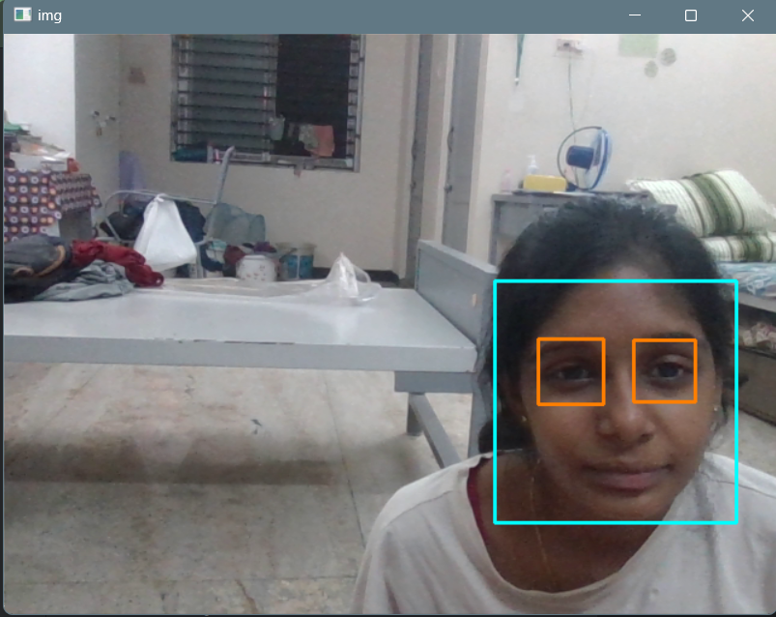

# **YOLO v5 Based Object Detection: (both for pretrained and custom data- (i/p -Video, Image, Live Video))**

**CODE:**

**Setup:**

!git clone https://github.com/ultralytics/yolov5 # clone

%cd yolov5

%pip install -qr requirements.txt comet_ml # install

import torch import utils

display = utils.notebook_init() # checks

from google.colab import drive drive.mount('/content/drive')

**Detect:**

!python detect.py --source "/content/drive/MyDrive/datasets/chicken video.mp4"

!python detect.py --weights yolov5s.pt --img 640 --conf 0.25 --source data/images # display.Image(filename='runs/detect/exp/zidane.jpg', width=600)

**Validate:**

# Download COCO val torch.hub.download_url_to_file('https://ultralytics.com/assets/coco2017val.zip', 'tmp.zip') # download (780M - 5000 images)

!unzip -q tmp.zip -d ../datasets && rm tmp.zip # unzip # Validate YOLOv5s on COCO val

!python val.py --weights yolov5s.pt --data coco.yaml --img 640 --half

**Train:**

#@title Select YOLOv5

logger = 'Comet' #@param ['Comet', 'ClearML', 'TensorBoard']

if logger == 'Comet':

%pip install -q comet_ml

import comet_ml; comet_ml.init() elif logger == 'ClearML':

%pip install -q clearml

import clearml; clearml.browser_login() elif logger == 'TensorBoard':

%load_ext tensorboard

%tensorboard --logdir runs/train

# Train YOLOv5s on COCO128 for 3 epochs

!python train.py --img 640 --batch 16 --epochs 3 --data coco128.yaml --weights yolov5s.pt

--cache

**OUTPUT:**

**IMAGE:**

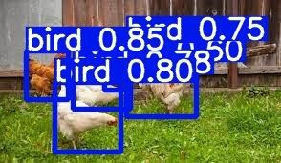

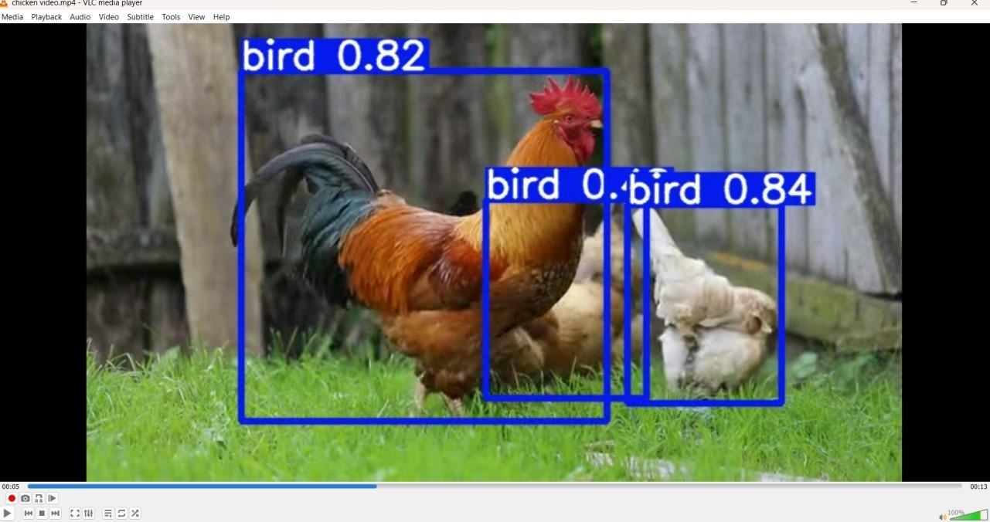**VIDEO:**

# **Object Detection using Deep Learning camera:**

**OUTPUT:**

# 

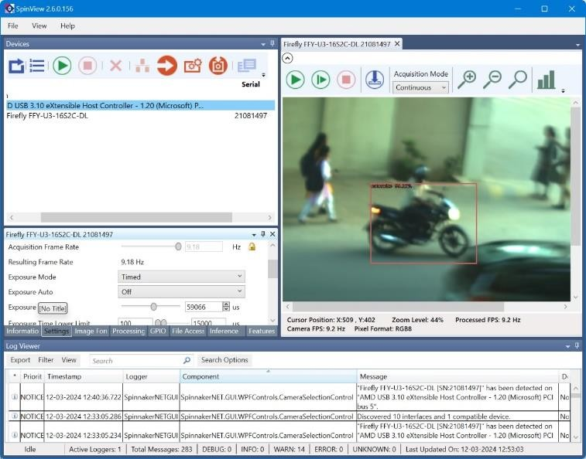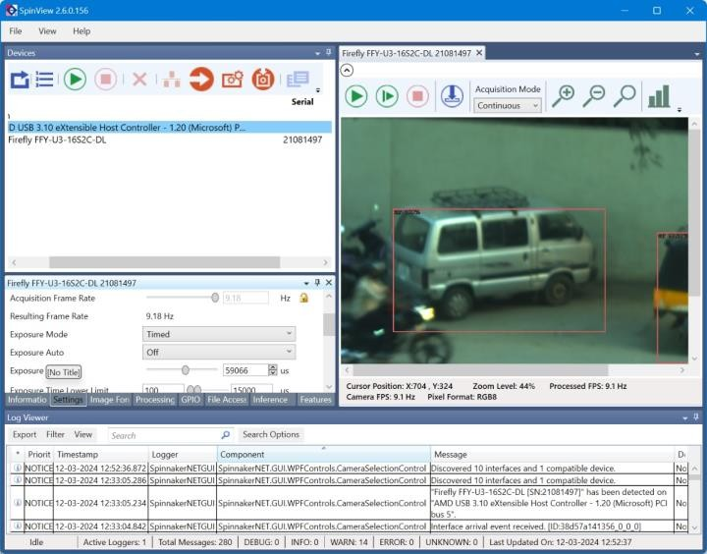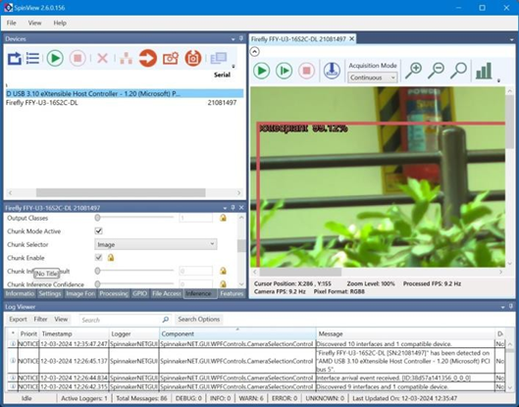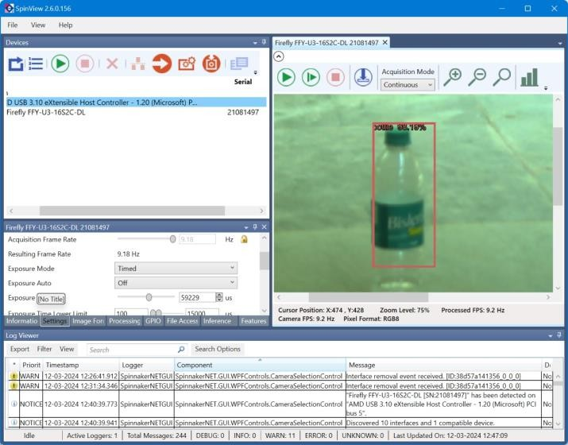

**Post Lab Questions**

1. **What are the key advantages of using Haar Cascades for face detection compared to other methods?**

**Fast Processing**: Haar cascades are computationally efficient, making them suitable for real-time applications.

**Robustness:** They can detect faces under various conditions such as changes in lighting, facial expressions, and minor occlusions.

**Pre-trained Models**: Haar cascades come with pre-trained models for face detection, saving time and computational resources during implementation.

**Simple Implementation**: Haar cascades are relatively simple to implement and understand, making them accessible to developers with varying levels of expertise.

1. **What are the difference between ANN & CNN.**

| **Feature** | **Artificial Neural Network (ANN)** | **Convolutional Neural Network (CNN)** |
| --- | --- | --- |
| **Architecture** | Consists of interconnected layers of neurons, including input, hidden, and output layers. | Employs specialized layers such as convolutional, pooling, and fully connected layers. |
| **Feature Learning** | Not specifically designed for feature extraction from structured data like images. | Specifically designed for feature extraction from images, utilizing convolutional layers. |
| **Parameter Sharing** | Each neuron in one layer is connected to every neuron in the subsequent layer, leading to a large number of parameters. | Utilizes parameter sharing and local connectivity through convolutional layers, reducing the number of parameters. |
| **Application** | Widely used in various tasks such as classification, regression, and clustering across different domains. | Particularly effective in image recognition, object detection, and tasks involving spatial data analysis. |

1. **For the following image perform the convolution operation. Also perform Max pooling, Min pooling and Average pooling on the input image.**

|  |  |  |
| --- | --- | --- |
| 3 | 2 | 4 |
| 2 | 0 | 2 |
| 4 | 2 | 3 |

**INPUT**

*from keras.models import Sequential*

*from keras.layers import Conv2D, MaxPooling2D, AveragePooling2D*

*# Create a sequential model*

*model = Sequential()*

*# Add a convolution layer with 32 filters, a kernel size of 3x3, and 'relu' activation*

*# function to the model*

*model.add(Conv2D(32, kernel_size=3, activation='relu', input_shape=(28,28,1)))*

*# Add a max pooling layer with a pool size of 2x2 to the model*

*model.add(MaxPooling2D(pool_size=2))*

*# Add an average pooling layer with a pool size of 2x2 to the model*

*model.add(AveragePooling2D(pool_size=2))*

*Print the summary of the model*

*model.summary()*

**Input Matrix:**

[[6 5 4 3 2 1]

[ 7 6 5 4 3 2]

[ 8 7 6 5 4 3]

[ 9 8 7 6 5 4]

[10 9 8 7 6 5]

[10 10 9 8 7 6]]

**Filter Matrix:**

[[3 2 4]

[2 0 2]

[4 2 3]]

**Output Matrix after Convolution:**

[[132. 110. 88. 66.]

[154. 132. 110. 88.]

[176. 154. 132. 110.]

[194. 176. 154. 132.]]

**Input Matrix:**

[[ 6 5 4 3 2 1]

[ 7 6 5 4 3 2]

[ 8 7 6 5 4 3]

[ 9 8 7 6 5 4]

[10 9 8 7 6 5]

[10 10 9 8 7 6]]

**Max Pooled Matrix:**

[[ 7. 5. 3.]

[ 9. 7. 5.]

[10. 9. 7.]]

**Min Pooled Matrix:**

[[5. 3. 1.]

[7. 5. 3.]

[9. 7. 5.]]

**Average Pooled Matrix:**

[[6. 4. 2. ]

[8. 6. 4. ]

[9.75 8. 6. ]]

# 

# S

# **Result:**

Thus Face Detection using Haar Cascade and Object Detection using Yolo V5 were performed.